2.51: a) From Eqs. (2.17) and (2.18), with v₀=0 and x₀=0,

b) For the velocity to be a maximum, the acceleration must be zero; this occurs at t=0 and 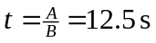. At t=0 the velocity is a minimum, and at t=12.5 s the velocity is

